TEACHER KEY: Student Handout
Mapping
BEACO2N aims to give insight into understanding greenhouse gas emissions through their work of providing almost real-time data on air pollutants through BEACO2N nodes located across the Bay Area. To learn more about BeaCO2N and its mission, feel free to read more at beacon.berkeley.edu/about.

Conceptual Review
We have become very familiar with datasets that deal with air pollutants. Let’s go over some conceptual questions about air pollution/geospatial data.
- Briefly describe what air pollution is and how it is caused. How do air pollutants move through the atmosphere?
______________________________________________________________________________________________________________________________________________________________________________________________________________________________________________________________________________________________________________________________________________________________
- Write each air pollutant and its respective units of measurement.
______________________________________________________________________________________________________________________________________________________________________________________________________________________________________________________________________________________________________________________________________________________________
- Why is it important to use maps? When should we use line plots, over histograms, over maps/GIFs?
Maps are the best way of displaying geospatial data. The primary uses for line plots are for showing trends/patterns over time with some continuous variable (not to represent geospatial data). The primary use for histograms is for displaying the frequency distribution of a single continuous numeric variable to understand how the data is spread out and identify skewness (not to represent data over time). We want to use maps/GIFs for displaying data with geographical components especially to analyze trends over time or over space. GIFs can be more helpful when we want to see the changes in space over time. We don’t want to use these for very detailed data or data that we want to have a close view of specific numerical values; that is better with line plots and histograms!

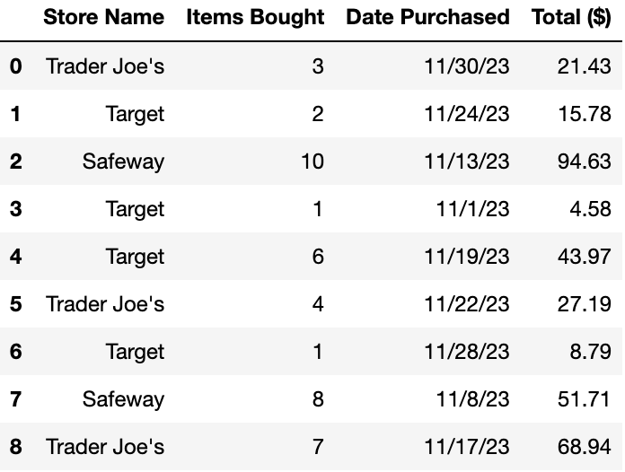
Assume we can access data from Trader Joe’s, Target, and Safeway. The table on the left displays this data. Use it to answer the questions in Sections 2 and 3.
Note: This dataset is completely made up for the purpose of these questions.
Assume this DataFrame is assigned to the store_data variable.

Learning About the Data (Data Granularity)

- What does each row in store_data represent? What information does this DataFrame tell you?
Each row represents 1 customer’s purchase from 1 store. This DataFrame tells us the name of the store, the number of items purchased, the date they purchased these items, and the total amount they spent for those items at that store.

- What is the data type (ie, string, int, float, timestamp) of each column? Indicate the unit of measurement for any column(s) that have units.
Store Name: string (str)
Items Bought: integer (int)
Date Purchased: timestamp
Total ($): float (units = US Dollar)

Grouping Data

As we can see from the notebook, grouping data can tell us some interesting things! One attribute we can group by with the store_data DataFrame is Store Name.
- Let’s say we were to run the below code. Describe what it will output! Feel free to draw out the new DataFrame and/or describe it.
store_data.groupby("Store Name").sum()
The columns of the DataFrame that this returns will be “Store Name”, “Items Bought sum”, “Date Purchased sum”, “Total ($) sum”. There will be 3 rows – 1 per unique store name! The values in the sum columns will include the total of each store for that column. ie) The “Items Bought sum” column will have these values:
Trader Joe’s → 14 (= 3 + 4 + 7)
Target → 10 (= 2+1+6+1)
Safeway → 18 (= 10+8)
- Let’s say we were to run the below code. Describe what it will output! Feel free to draw out the new DataFrame and/or describe it.
store_data.groupby("Store Name").mean()
The columns of the DataFrame that this returns will be “Store Name”, “Items Bought mean”, “Date Purchased mean”, “Total ($) mean”. There will be 3 rows – 1 per unique store name! The values in the mean columns will indicate the average of the values in that column for each store. ie) The “Items Bought mean” column will have these values:
Trader Joe’s → 4.667 (= (3+4+7)/3)
Target → 2.5 (= (2+1+6+1)/4)
Safeway → 9 (= (10+8)/2)

Visualizing Spatial Data

Now let’s jump into understanding and visualizing maps.

Part 1: Understanding Shapefiles
In the In-Class and Student Exploration notebook, we ran cells that created the map of the Bay Area. These maps are all created by reading a shapefile.
Definition: A shapefile is a popular geospatial vector data format for analyzing geographic information. Created by Esri, shapefile consists of a collection of files with extensions like .shp (shape format), .shx (shape index format), and .dbf (attribute format).
Note: While you do not have to understand all the collection of files, you can further investigate by looking into the data files used for this Notebook if you are interested in data processing, analysis, and processing! You can see the collection files in the beacon-mapping-files-main folder by clicking on the folder icon on the left menu bar in your notebook.

Part 2: Understanding Maps

When looking at maps, we can look at their latitude and longitude as features. Latitude and Longitude are a set of coordinates used to determine the precise location of any point on the Earth's surface.
- Latitudes are horizontal lines running from East to West, indicating north-south positions.
- Longitudes are vertical lines running from North to South, indicating east-west positions.
In the following questions, we will look at different sets of latitude and longitude. Go to Google Maps and type in these geographical vector points to answer what recognized landmarks are represented by these latitudes and longitudes.
Example: Coordinates 35.36139452784725, 138.72706293491046 ⇒ Fuji, Japan
- What famous landmark is located at these coordinates: 51.50082268197, -0.12462943021060194?
Big Ben, London, UK
- What famous landmark is located at these coordinates: 48.858490069828335, 2.294534941194745?
Eiffel Tower, Paris, France
- What famous landmark is located at these coordinates: 37.82703327196858, -122.42308536308465?
Alcatraz Island, San Francisco, USA
- What famous landmark is located at these coordinates: 41.89039386784884, 12.492263083143206?
Colosseum, Rome, Italy
- What famous landmark is located at these coordinates: -33.856597271920684, 151.21526450975105?
Opera House, Sydney, Australia
- What famous landmark is located at these coordinates: 43.089710944542134, -79.0851896189112?
Niagara Falls, Ontario, Canada

The first letter of these recognized landmarks should spell BEACON!
Part 3: Analyzing Data within a Map
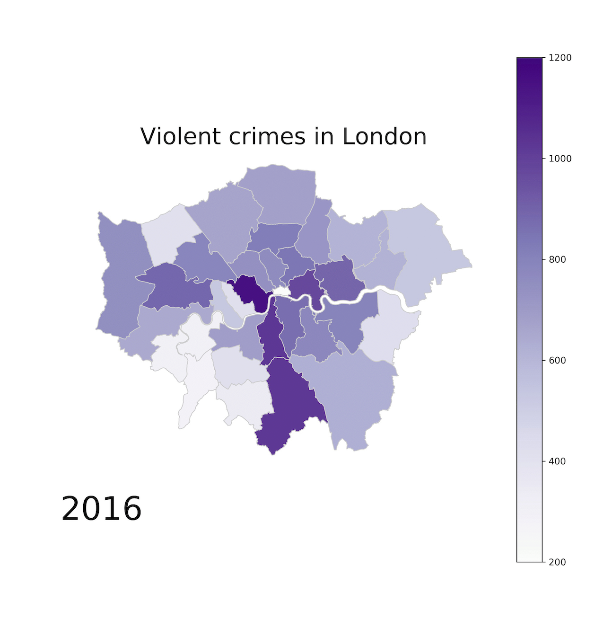
Let’s say we are working with London crime datasets.

(Map created by Ben Dexter Cooley)
Each point or shaded area on the map represents a specific geographic location where data was collected or an event occurred, in this case, instances of violent crime. While we had points/dots representing data in the Mapping Notebook, this graphic uses the shade for each borough (district) in London to represent the data. This was done by aggregating the collection of data points in each borough. Darker shades typically indicate higher values in the color scale, whereas lighter shades indicate lower values – but always verify the colormap! With these features in mind, let’s answer some conceptual questions below.
- How do the concentrations of data points relate to the geographic features of the area (ie, urban vs. rural, proximity to landmarks, etc.)? Use this map of London (by borough) [https://londonmap360.com/london-boroughs-map] and its descriptions (or Google!) to find these details and compare.
The Westminster Borough has the highest violent crime value. Westminster is the biggest tourist area in London! It has the Big Ben, Westminster Abbey, Buckingham Palace, and the Houses of Parliament, which are some of London’s biggest landmarks which lots of people visit. Places like Merton (in Southwest London) are white or light purple on the map and they’re described to be rural – “The South West London borough of Merton offers an escape from the city bustle [...] with its peaceful open spaces and family-friendly housing.”

- What patterns can you discern from the distribution of violent crimes in London as shown on the map?
Possible patterns identified:
- Central Urban Areas: Violent crime may be higher in central/downtown areas of London due to greater population density and other factors.
- Tourist attractions: Tourists are often targetted for petty crime, which can drive the crime rate higher.
- Transportation Hubs: Areas around major transportation hubs (train stations, etc.) sometimes see increased crime rates.
- Entertainment Districts: Areas with high concentrations of bars and nightclubs could show a rise in violent incidents, especially late at night or on weekends.
- How might policymakers or law enforcement use this data to allocate resources or plan interventions to prevent violent crimes?
______________________________________________________________________
Students can have a variety of answers! Here are some ideas:
- Targeted Policing: If law enforcement identifies high crime hotspots and deploys focused patrols to those specific areas, this would increase police presence and deter potential offenses.
- Proactive Patrols Based on Time: If patterns show specific times of day or days of the week with higher violent crime incidents, adjust patrol schedules to have increased presence during those periods.
- Infrastructure Investment: Target infrastructural improvements like better street lighting or security cameras in crime hotspots to increase visibility and potential deterrence.
- For intervention planning, there could be social programs implemented on identified hotspot areas! This could include youth outreach programs, job training initiatives, or neighborhood revitalization projects aimed at addressing underlying socioeconomic factors that contribute to crime.
- Data-Driven Problem Solving: Use the insights from the maps to engage in Problem-Oriented Policing models. This involves identifying recurring crime problems, analyzing the root causes, and developing responses beyond traditional policing measures.

